BUTANE DOCKING

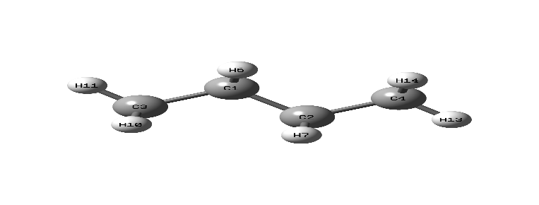

Fig. 1. Butane Opt structure

**THE CURPOCKET CAVITY DATA FROM YOUR CB-DOCK2 RESULTS, PADMAVATHI! HERE'S A CLEAR BREAKDOWN OF EACH CAVITY AND HOW YOU CAN USE THIS INFORMATION FOR LIGAND DOCKING, POSE VISUALIZATION, AND GUI INTEGRATION IN CHEMINSIGHT LAB:**

**Summary of Detected Cavities in 1U72**

| **Cavity ID** | **Volume (Å³)** | **Center (x, y, z)** | **Size (x, y, z)** | **Notes** |
| --- | --- | --- | --- | --- |
| **C1** | 2008 | (32, 16, 2) | (15, 22, 17) | Largest pocket; ideal for flexible or bulky ligands |
| **C2** | 224 | (17, 8, 11) | (15, 6, 9) | Narrow and elongated; may suit linear ligands like butane |
| **C3** | 207 | (17, 21, –10) | (10, 8, 7) | Deeper pocket; good for hydrogen bonding interactions |
| **C4** | 195 | (13, 1, 0) | (12, 6, 6) | Compact; may stabilize small polar ligands |
| **C5** | 164 | (22, 10, –17) | (9, 7, 5) | Smallest; best for hydrophobic fragments or alkyl chains |

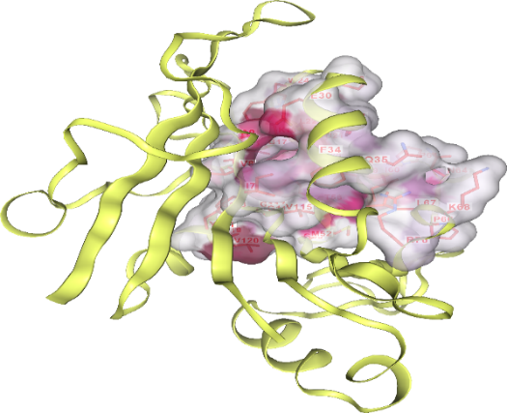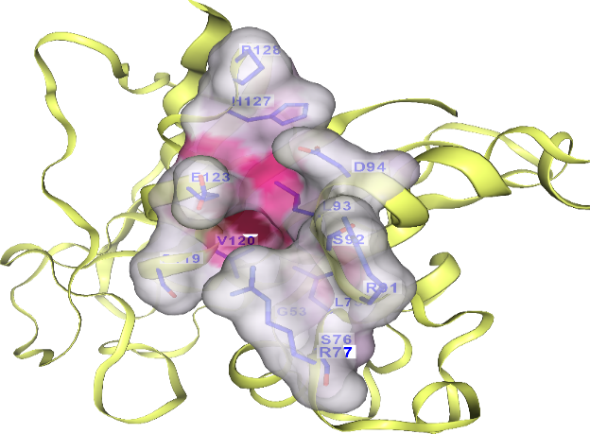

C1 C2

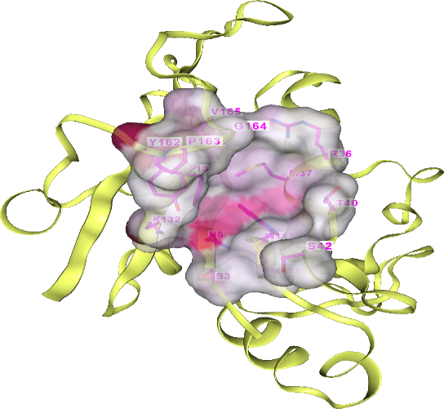C3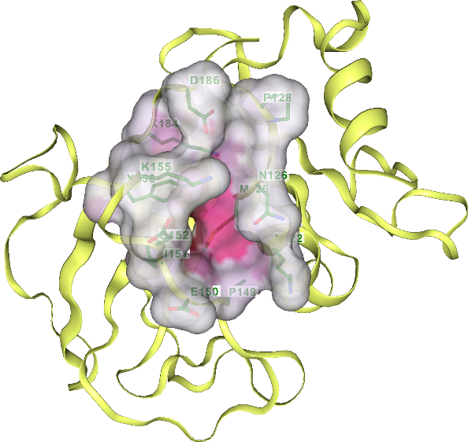C4

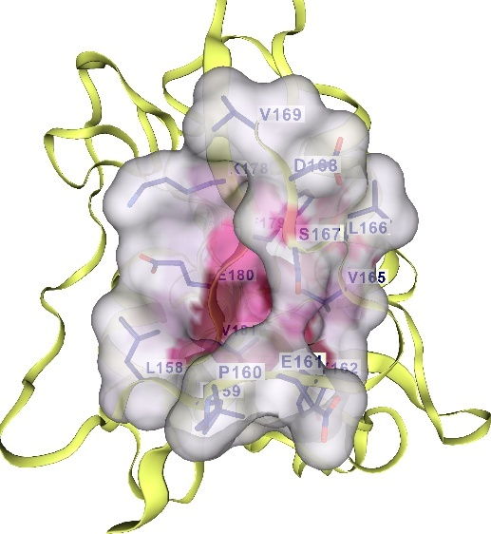C5

**Docking Summary**

| **CurPocket ID** | **Vina  score** | **Cavity  volume (Å3)** | **Center (x, y, z)** | **Docking size (x, y, z)** |
| --- | --- | --- | --- | --- |
| **C1** | -2.9 | 2008 | 32, 16, 2 | 20, 27, 22 |
| **C2** | -2.4 | 224 | 17, 8, 11 | 20, 14, 14 |
| **C5** | -2.4 | 164 | 22, 10, -17 | 14, 14, 14 |
| **C4** | -2.3 | 195 | 13, 1, 0 | 14, 14, 14 |
| **C3** | -2.1 | 207 | 17, 21, -10 | 14, 14, 14 |

| **Ligand Name** | **Cavity ID** | **Docking Score (kcal/mol)** | **Pose File** | **Notes** |
| --- | --- | --- | --- | --- |
| e.g., Butane | C1 | –2.9 | butane_C1.pdb | Best fit for linear alkane |

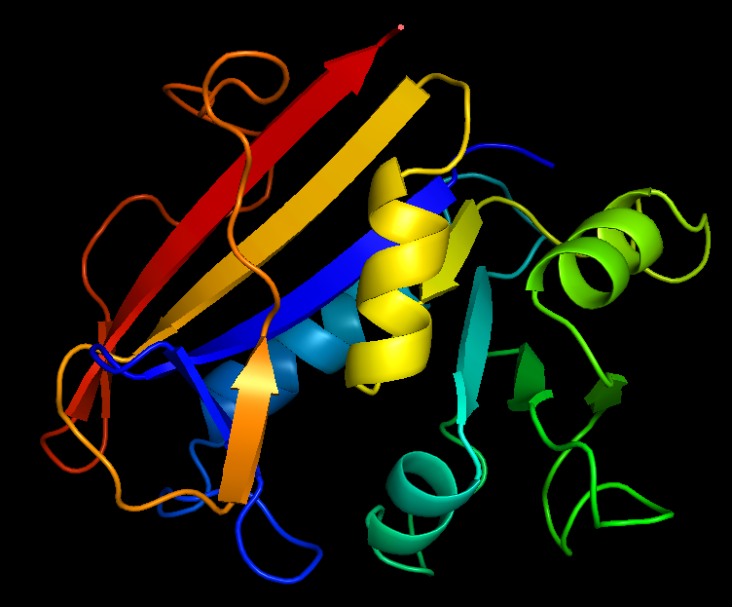

1U72-Butane Docking - pymol